PHASE V : PERFORMANCE TESTING AND VALIDATION

Date | 06 November 2025
Team ID | 7DDB99C3AFBFD678BC14B32342A420F8
Project name | Medical Inventory Management
Maximum Marks | 4 Marks

Title: Brainstorming for “Medical Inventory Management”

1.Objectives :
The main objectives of Performance Testing and Validation in Medical Inventory Management are to ensure that the system operates efficiently, reliably, and consistently under various load conditions. It aims to evaluate how effectively the system handles large volumes of medical inventory data, multiple user interactions, and high transaction rates without delays or failures. This process helps verify that the response times for critical operations such as stock updates, order processing, and inventory searches meet the required performance standards.

- To ensure that the system functions correctly according to requirements.

- To verify that all features are stable, reliable, and easy to use.

- To check performance under different loads and user conditions.

- To identify and fix defects before deployment.

- To ensure the system is secure, scalable, and user-friendly.

2. Overview of Testing Strategy :

The testing strategy followed a combination of manual and automated testing approaches.
Different testing levels such as Functional Testing, Security Testing, Usability Testing, Performance Testing, and Feedback Evaluation were carried out. Each module was tested individually and then integrated to ensure smooth workflow.

Testing Type | Purpose / Description | Key Focus Areas | Expected Outcome
Unit Testing | To test individual modules or components of the system. | Validation of functions like stock entry, search, and update. | Each module performs accurately and independently.
Integration Testing | To ensure that different modules work together correctly. | Interaction between inventory, user, and order modules. | Smooth data flow and communication between components.
System Testing | To test the complete system as a whole. | Full workflow from inventory entry to order completion. | System functions correctly in real-life scenarios.
Performance Testing | To measure speed, scalability, and responsiveness. | Load handling, response time, and throughput. | System remains efficient under different load conditions.
Stress Testing | To test system behavior under extreme load or stress. | High data input and multiple concurrent users. | System remains stable without crashing or data loss.
Security Testing | To ensure data protection and user access control. | Authentication, authorization, and data encryption. | System is secure against unauthorized access and breaches.

3. Functional Testing :

- Verified whether all modules, buttons, and input fields work as expected.

- Tested workflows such as data entry, updates, search, deletion, and report generation.

- Checked for expected outputs with valid and invalid inputs.

- Ensured system behavior matches specification and user requirements.

- Outcome: All core functions performed correctly after minor bug fixes.

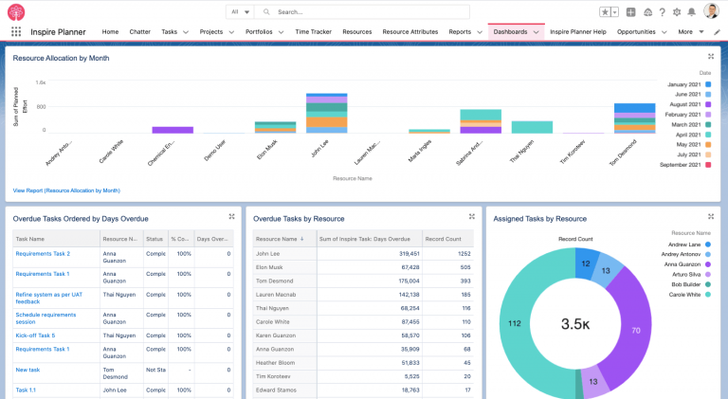
This Photo by Unknown Author is licensed under CC BY-SA

4. Security and Access Control Testing

- Verified login authentication, password encryption, and role-based access.

- Checked unauthorized data access prevention.

- Tested secure session handling and logout behavior.

- Ensured sensitive data is protected from misuse.

- Outcome: System supports protected access and prevents unauthorized use.

5. Usability and Dashboard Testing :

- Evaluated simplicity and clarity of UI design.

- Checked button placements, navigation flow, and readability.

- Ensured dashboard displays key information clearly (e.g., stock levels, alerts, requests).

- Tested whether new users can operate the system with minimal training.

- Outcome: Dashboard is user-friendly, intuitive, and efficient for daily use.

6. Automation and Performance Testing

- Selected repetitive workflows (ex: form submissions, data retrieval) for automation.

- Measured response times for common user actions.

- Ensured system runs smoothly without lag during high usage.

- Outcome: System performs consistently with fast response time.
7. Load Testing and Scalability :

- Tested system performance under increasing number of users and data volume.

- Observed behavior when large records were stored or when many simultaneous operations occurred.

- Verified that system can scale with growing data or user base.

- Outcome: System remained stable and scalable within acceptable limits.

8. End User Feedback Analysis

Feedback was collected from real users (staff / volunteers / testers) during trial usage:

Feedback Area |  | User Comment | Action Taken
Ease of Use |  | Interface is simple | No change needed
Response Speed | Works quickly Confirmed |  |  | performance is good
Feature Suggestions | Users requested quick search/filter |  |  | Search feature improved

Outcome: Feedback helped improve usability and minor feature refinement.

9. Summary of Testing Results

- All major functions work correctly as intended.

- System meets quality standards for usability, security, and performance.

- Identified minor issues during testing, which were resolved successfully.

- End users found the application easy and efficient to use.

10. Conclusion :

The testing process confirmed that the system is stable, user-friendly, secure, and reliable. It meets the functional requirements and performs well under different operational conditions. Based on the testing outcomes, the system is ready for deployment and practical use. In conclusion, Performance Testing and Validation play a crucial role in ensuring the effectiveness and reliability of the Medical Inventory Management System.
- Through systematic testing under various load and stress conditions, the process verifies that the system performs efficiently, responds quickly, and maintains stability during peak operations.

- It ensures that the application can handle real-time data processing, multiple user interactions, and large-scale inventory management without performance degradation.

- Additionally, validation confirms that the system meets all functional and non-functional requirements, complies with healthcare standards, and provides accurate, consistent results.

